SOMALILAND ENGINEERSING ASSOCITION
https://seasomaliland.org
☏ 252-634054030/654054030||252-634180330||252-63479953

Gabilley Traditional and geophysical water exploration

2026

National Presidents will (His excellence Cabdiraxman Mohamed Abdillahi) to find a Clean Drinking Water to The Town of Gabilley

Project Proposal

“Traditional and geophysical water exploration” from Deep South &west Gabiley explorable field W/Sources finding

, (Requested by the Governor (Gov Mohamed Cabdilahi bookh)

Authorized by the Ministry of Water development and Ministry of Planning of The Republic of Somaliland

With the collaboration of The
Somaliland Engineers’ Association,

Total Budget for a System producing 120M^{3 .}Per Day. $638,320USD

Executive summary:
The groundwater in Gabiley areas can be divided into two categories: pore water and fracture water. Unlike fracture seepage, sandstone pore seepage in deep G/water manifests as a large area and is difficult to plug via conventional grouting methods. This study focused on pore seepage in deep South &west Gabiley explorable field to improve the grouting eﬀect. Taking the deep South &west Gabiley explorable field in the area, where “large-area sweating” seepage occurs, as the study object, this study examined the pore structure, petrological characteristics, physical properties, and grain sizes of the sandstone by analyzing experimental data from thin sections and scanning electron microscopy samples. The formation mechanism of the “large-area was then analyzed. The range of permeability in which “large-area may occur in the sandstone was discussed. The results indicate that the process of “large-area spring” seepage in deep South &west Gabiley explorable field can be divided into a matrix softening stage, a matrix erosion stage, and a “large-area sweating” water seepage formation stage. According to the case analysis on the “large-area in the Looka-aroor and Gogolwanag waterfield, the lower limit of permeability of the area sandstone is approximately 0.25 mD. Thus, this type of seepage can occur in deep South &west Gabiley explorable sweat water field with a permeability of greater than 0.25 mD and aﬀect typical mining production. The results of this study provide information about the formation mechanism of “large-area water seepage from sandstone pores and can theoretically inform the development of a new permeation grouting technique.


Introduction
Over the last two decades, due to a large number of deep underground water engineering projects, the impacts of ground- water seepage through pores cannot be ignored [1]. For example, coal is an important form of energy and an indus trial raw material that is used worldwide. Developing deep underground coal resources is inevitable because longterm mining is gradually reducing shallow coal resources [2]. Most of the strata that are crossed by deep mining shafts are sedimentary sandstones with abundant water and devel- oped pores [3]. The phenomena of water seeping and gushing from shaft walls often occur during shaft construction. Years of grouting sandstone aquifers to plug water seepage in deep boreholes show that even when cementing and chemical grouting are carried out in the rock mass behind the wall and the main water inflow channels caused by fractures in the rock mass are eﬀectively found, residual water still extrudes through sandstone pores on the shaft wall. Such extrusion cannot be ignored because the total water yeild exceeds the upper limit of the accepted specification (≤10 m³/h) [4, 5].

To date, scholars have studied the pore struc ture and the groundwater seepage, including the pore struc ture of materials, (the pore structure of petroleum and gas reservoirs), the groundwater seepage of rock fractures, and pore seepage of Quaternary sandy soil. we studied the influence of porosity on the properties of various materials [7, 8]; a (other scholars can study the pore structure in oil and gas reservoirs to understand its impact on the quality, migration, and accumulation of oil and gas [9–13]. we studied the seepage characteristics of rock fractures and their impacts on engineering construction because such fractures usually have a good hydraulic conductivity. Quaternary sandy soil has a loose structure and abundant pore water, which is a primary concern for hydrogeology and civil engineering projects. SEA present and validate an analytical model of water inflow and rising level in a flooded areas by comprehensively considering various voids and the heterogeneities of rocks. The results of the above studies inform the continued study of pore seepage in sandstone. However, because the small area of shallow sandstone generally pro duces a small seepage discharge, the prevention and control of pore water in shallow sandstone are often ignored. To date, the formation mechanism of water seepage from sandstone pores has not been investigated fully, and the cause, process, and conditions of such seepage are unclear. In fact, as mentioned above, with the deepening of water aquiver yields and the increasing discharge from deep boreholes and shallow ones has increased significantly, and this issue requires immediate attention. Therefore, this study focused on the water to be tapped to the town oF Gabilley, proposed by the Governor (Gov mohmaed bookh) and the MPs elected in the Region ( MPa Ahmed Abdi Ibrahim Timajilic) as well as the entire inhapitants. the characteristics of the pore seepage, and assessed the for- mation mechanism and conditions of “large-area water seepage from deep sandstone pores. The aim of this study was to provide technical support for the prevention and control of drought to the inhabitants and fed from deep water boreholes of rocky sandstone pores in underground engineering projects.

Samples and Methods
  - Structural Logistics Scheme of This Study. An overview of the flow of this study is shown in Figure 1. Taking the deep South &west Gabiley explorable field in the as examples were collected, and appropriate experimental methods were determined. Next, the pore structure, petrological characteristics, physical properties, and grain sizes of the sandstone were carefully studied by analyzing experimental data from casting thin sections and scanning electron microscopy (SEM) samples. The formation mechanism of water seepage from deep South &west Gabiley explorable field pores was analyzed, and the formation conditions for this type of seepage were discussed by taking the ventilat ing shaft of the Lagbarako deep waters.
  - Sample Collection. All deep South &west Gabiley explorable field samples in this study were collected from typical sections with three layers of sandstone aquifers in the deep coal mines in the Southwest Shandong coalfield, as shown in Figure 2 in orange. The strata in the Southwest Shandong coalfield are part of the West Shandong stratigraphic subprovince, which is part of the North China stratigraphic province. From old to new, Ordovician, Carboniferous, Permian, Jurassic, Paleogene, Neogene, and Quaternary strata are present [23, 24]. The three most widespread layers of sandstone aquifers are Permian Shiilcad Formation sandstone, Permian sandgrain Formation sandstone, and Jurassic sandstone, which are widely distributed in the Southwest Shandong coalfield and have an important impact on coal mining [25]. In this study, more than 100 m of drilling cores from the 2 wells of core samples were collected.

  - Experimental Methods. All samples were transported to the laboratory; the samples were sealed to retain moisture and held under pressure. samples were used to test the porosity and permeability with STY-2 gas permeability and porosity meters according to the specifications of the Core Analysis Method (GBT 29172-2012) [26] Additionally, to observe the composition and texture of the grains and the pore structure of the sandstone, a size -2M polarizing microscope and a Nova Nano Sem450 SEM were used with the group (b) and group (c) samples. Furthermore, the grain size of the sandstone was analyzed using a Mastersizer 3000E grain size analyzer with the group (d) samples. The experimental sample sizes are shown in Figure 3.

Results and Analysis
  - Petrological Characteristics. The petrological characteris tics of the deep South &west Gabiley explorable field are shown in Table 1. According to the casting thin section and SEM observations, the primary clastic grains of the deep South &west Gabiley explorable field in the study area are quartz, feldspar, and various kinds of rock debris. Nevertheless, the proportion of clastic grains in different sandstones varies. The Jurassic sandstone is mainly purplish red lithic arkosic sandstone with a relatively low clay matrix content, mostly 2%5% and rarely 5%-12%. The Shiilcad Formation sandstone is mainly gray lithic feld- spathic quartz sandstone with a high clay matrix content, generally 5%-12%. The Dixi Formation sandstone is mainly gray–white feldspathic lithic sandstone with a high clay matrix content, typically 5%-12%.

  - Pore Structure. According to the experimental data and considering the occurrence and genesis of pores, the pore types of the deep South &west Gabiley explorable field in the Southwest Gogolwanag are divided into intergranular pores, intragranular pores, intercrystalline pores, and microfratures. The contents of the three main pore types are shown in Table 2.

The samples




Discussion
Theoretical analysis methods Theory of sedimentary petrology
Theory of multivariate statistical analysis
Linear (radial) vadose theory
Understanding the formation mechanism of water seepage from the pores of deep mine sandstone

Conclusions
Research object: Three layers of sandstone crossed by the ventilation shaft and distributed widely in the south/west Gabiley explorable field.
Methods
Experimental methods
Optical casting thin section observations SEM observations
Grain size analysis
Porosity and permeability tests
Formation condition: In what types of deep mine sandstone does ‘‘large-area sweating’’ water seepage occur?
Figure 1: A general overview of the flow of this study.

0
–100
–200
–300
Altitude (m)
–400
–500
–600
–700
–800
–900
S32 S26 S33 S34 S27 C12-8

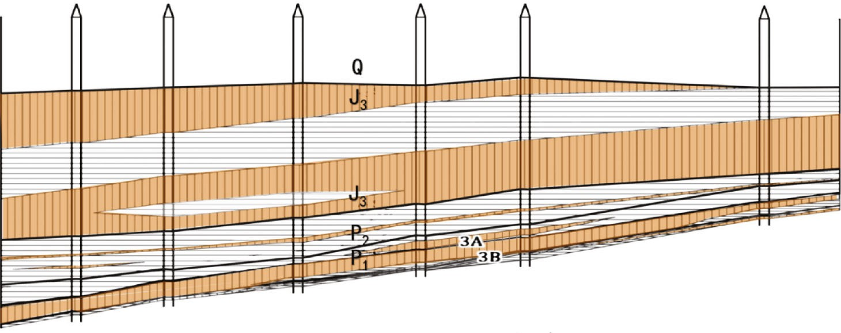
0
–100
–200
–300
–400
–500
–600
–700
–800
–900

Legend
J3
P₁

Drill holes Quaternary Stratum boundary Aquicludes Jurassic system
Q

Sandstone aquifers

Permian sandgrain formation
P₂

3A water layer
Permian Shiilcad formation

Figure 2: Distribution of samples into groups for laboratory research: (a) Jurassic sandstone; (b) Permian Didib Formation sandstone; and
(c) Permian Dixi Formation sandstone.

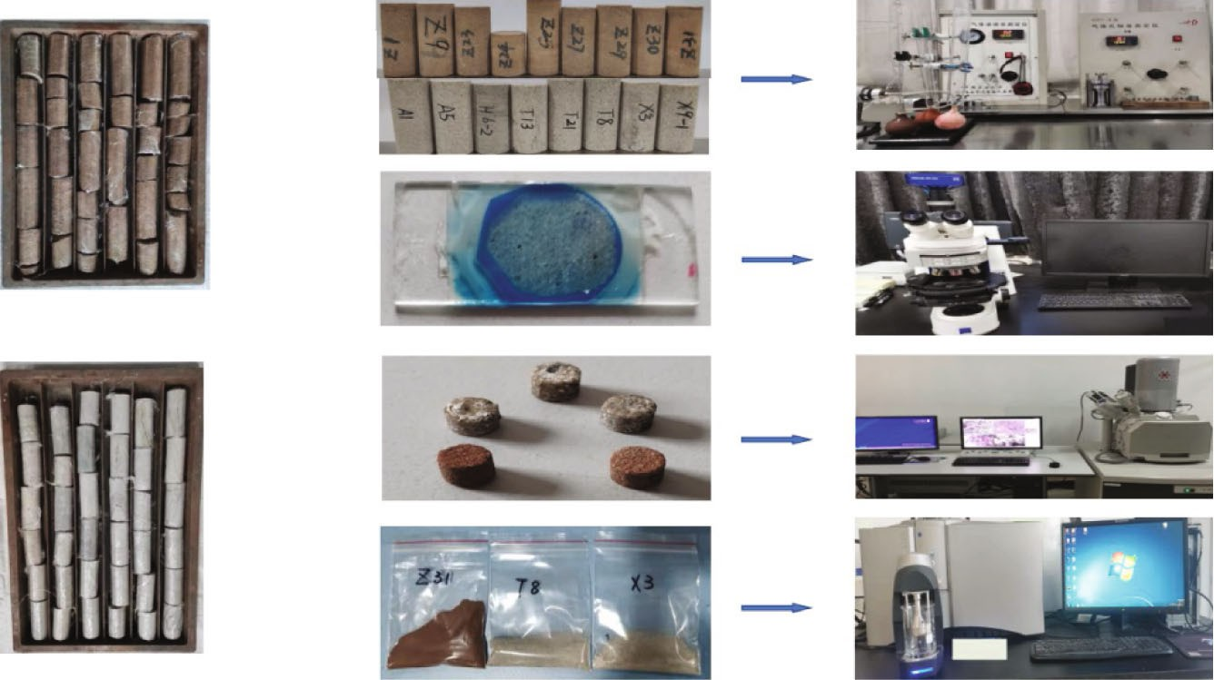
Group (a)
Group (b)
Original samples
Group (c)
Group (d)

Figure 3: The original samples were divided into four groups to carry out various laboratory tests. (a) Height 25.4-50.8 mm and diameter
25.4 mm for the porosity and permeability tests. (b) Casting thin sections for the size Imaging-2M polarizing microscope observations. (c) Height 6 mm and diameter 4 mm for the SEM observations. (d) Crushing, grinding, and removing cement with hydrochloric acid and drying for the grain sizes analysis.

Table 1: The petrological characteristics of deep South &west Gabiley explorable field.

Petrological characteristics | Jurassic sandstone | shilcad sandstone | Dixi sandstone
Main rock type | Lithic arkosic sandstone | Feldspathic quartz sandstone | Feldspathic lithic sandstone
Clay matrix (%) | Mostly 2-5, rarely 5-12 | 5-12 | 5-12
Cement | Siliceous, calcareous | Siliceous, calcareous | Siliceous
Compositional maturity | Low | Relatively low | Low
Sorting coefficient (So) | Well (1.15-1.37) | Medium-well (1.47-1.60) | Medium-well (1.16-1.93)

Grain shape Medium psephicity, subrounded-subangular
Medium psephicity,
subrounded-subangular
Medium psephicity,
subrounded-subangular

Cement type Porous Porous, contact Porous, contact Textural maturity Secondary immature Immature Immature

Table 2: Contents of the three main pore types in deep South &west Gabiley explorable field∗.

Sandstone type | Intergranular pores (%) | Intragranular pores (%) | Intercrystalline pores (%)
Jurassic sandstone | 3.2-10.1 | 0.7-1.7 | 0.1-0.2
sandgrain sandstone | 0.8-5.0 | 0.8-3.5 | 0.1-0.5
Shiilcad sandstone | 0.5-6.1 | 0.4-2.9 | 0.1-0.3
∗The contents in this table indicate the visual area percentage of the sandstone samples.

Table 3: Types and contents of intergranular pores in deep South &west Gabiley explorable field∗.

Sandstone types | Primary pores (%)  Original | Residual | Dissolved | Secondary pores (%)  Matrix pores
Jurassic sandstone | 2.5-9.0 | 0.1 | 0.1-0.5 | 0.5
sandgrain sandstone | 0.2 | 0.3-2.0 | 0.2-1.3 | 0.1-1.5
Shiilcad sandstone | 0.1-3.5 | 0.2-1.5 | 0.1-0.8 | 0.1-0.3
∗The contents in this table indicate the visual area percentage of the sandstone samples.

Intergranular pores are a vital pore type that aﬀects the permeability of deep water South &west Gabiley explorable field. This pore type can be divided further into primary intergranular pores and secondary intergranular pores. The original primary intergranular pores most aﬀected the permeability of the studied sandstone (see red arrows in Figure 4(a)); these pores are largely preserved in the Juras- sic sandstone and comprise 2.5-9.0% of the visual sandstone area, as shown in the bold green numbers in Table 3.
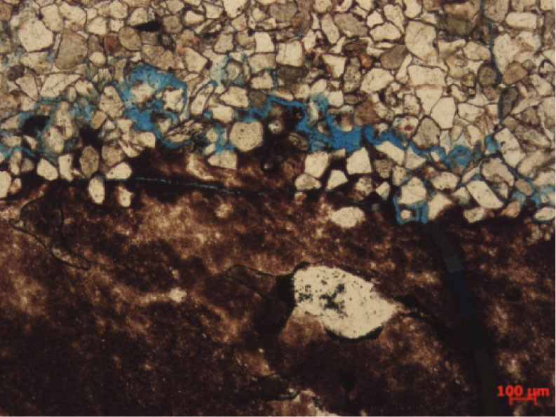
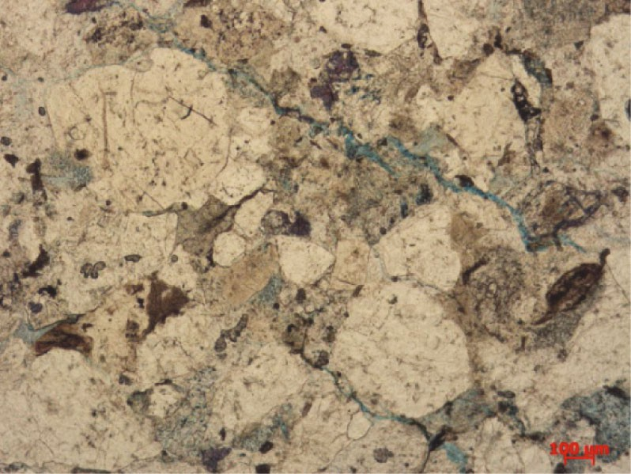
Bedding plane
100 𝜇m
100 𝜇m
- (j)
Figure 4: Pore types in the deep South &west Gabiley explorable field. (a) Jurassic sandstone, 1047.37 m, Z23 (-). (b) Permian sandstone, 1068.83 m, X9 (-). (c) Permian sandstone, S12 (-), 920.28 m. (d) Permian sandstone, 1007.22 m, S18 (-). (e) Permian sandstone, 920.98 m, S12 (-). (f) Permian sandstone, 1012.84 m, A1 (-). (g) Permian sandstone, 911.46 m, S10 (-). (h) Permian sandstone 1068.83 m, X9, SEM. (i) Jurassic sandstone, 1023.26 m, Z9 (-). (j) Permian sandstone, 1153.04 m, T13 (-).

However, the other types of intergranular pores are rare in Jurassic sandstone, and they comprise less than 0.5% of the visual area of the samples.
The original primary intergranular pores in the Permian
sandstone are much lower in number (see red arrows in | Jurassic sandstone | 0.5-2.5 | 0.2 | 0.0
Figure 4(b)). These pores comprise 0.1-3.5% of the visual | Shihezi sandstone | 0.5-2.5 | 0.2-0.5 | 0.1-0.5
area of the samples and have a large distribution deviation. | Shanxi sandstone | 0.2-1.5 | 0.1-0.2 | 0.1-0.2

Table 4: Types and contents of intragranular pores in deep South &west Gabiley explorable field∗.
Sandstone type Feldspar (%) Rock debris (%) Cleavage (%)

∗The contents in this table indicate the visual area percentage of sandstone samples
However, the other intergranular pores, including residual intergranular pores (see red rectangles in Figure 4(c)), sec- ondary intergranular pores (see red arrows in Figure 4(c)), and matrix intergranular pores (see red rectangle in Figure 4(d)), are relatively developed and comprise 0.1- 2.0% of the visual area of the samples, as shown in Table 3. Intragranular pores are more developed in Permian sandstone than in Jurassic sandstone, as shown in Table 4. The most developed intragranular pores in the three layers of sandstone are feldspar dissolved intraparticle pores (see red arrows in Figure 4(e)), rock debris dissolved intraparticle pores (see red arrows in Figure 4(d)), and feldspar cleavage pores (see red arrows in Figure 4(e)). Only a small number of moldic (see red arrow in Figure 4(g)) and broken grain
pores (see red arrow in Figure 4(f)) are present.
Intercrystalline pores formed during diagenesis. They are primarily found in the intercrystalline areas of calcareous cement and authigenic clay cement in the three layers of sandstone (see red arrows in Figure 4(h)); they are generally micropores with diameters less than 0.5 μm and are identi fied only under SEM. Because they are too small to grout, they are not the main object of this study.
Microfractures include bedding microfractures caused by sedimentation (see red arrow in Figure 4(i)) and struc- tural microfractures caused by tectonism (see red arrows in Figure 4(j)) in the three layers of sandstone. Along the strike direction of bedding microfractures and structural micro fractures, the permeability of the sandstone is improved sig- nificantly due to good pore connectivity.
the three most widespread layers of sandstone aquifers distributed widely in the Southwest Shandong coalfield are Permian Shiilcad Formation sandstone, Permian sandgrain Formation sandstone, and Jurassic sandstone [25]. The hydrogeological features of these sandstone aquifers are shown in Table 5.
The levels of water abundance for these sandstone aqui- fers are usually weak to moderate except when coupled with faults or folds. The so-called sweating seepage reported by many coal miners is an underground water seepage feature of these kinds of sandstone, i.e., water seepage through sand- stone pores is manifested as large areas of “sweating” rather than as a permeable state of “local spray,” and the water inflow rate is usually low (see Table 5). However, when a deep shaft passes through a large area of such sandstone, the amount of total seepage flow in the deep environment will become an engineering problem that cannot be ignored. According to the petrological characteristics of the sand- stone mentioned in Section 3.1, the deep South &west Gabiley explorable fields in the Southwest Shandong coal mine have three prominent petrological characteristics (see Table 1). First, the compositional maturity is low to relatively low, which manifests as high contents of feldspar and rock debris in the sandstone. Second, the textural maturity is immature to secondarily immature, which manifests as a high matrix content in the sandstone (generally 5%~12%), and SEM shows that the main components of the matrix are kaolinite (see Figures 5(b)–5(d)), illite, chlorite, and other clay minerals. Third, many calcareous cement types are present in the interstitial materials (see red arrows in Figures 5(e) and 5(f)). The above petrological characteristics laid an internal material foundation for various late diagenetic changes in the deep South &west Gabiley explorable field pore structure.
In contrast, compared with shallow environmental conditions, the deep mining environment is characterized by high water pressures, high temperatures, high pH values, and high carbon florine dioxide concentrations. Due to these conditions, unstable minerals, rock debris grains, and matrix and calcareous cements in the pores of deep South &west Gabiley explorable field can be damaged by various physical, chemical, and metasomatic eﬀects.
Moreover, various deep water South &west Gabiley explorable field intergranular pores initiate water seepage. As mentioned in Section 3.2, many primary and secondary intergranular pores are present in the deep water South &west Gabiley explorable field. In particular, original intergranular pores are common in the Jurassic sandstone, with good connectivity and 100% probability of appearance (see red arrows in Figure 5(a)). The original intergranular pores of Permian sandstone are much lower in number (see red arrows in Figure 5(b)) (see Table 3). Nevertheless, the other types of intergranular pores, such as residual inter- granular pores and secondary intergranular pores, are rela- tively developed.
Based on the above understanding, this process can be divided into three stages: a matrix softening stage, a matrix erosion stage, and a “large-area sweating” water seep- age formation stage.
In the matrix softening stage, with the deepening of the shaft excavation, the hydrostatic pressure in the sandstone on the shaft wall increases, and some coarse-grained sand- stone with developed intergranular pores begin to seep locally under the action of hydrostatic pressure at depth.

Additionally, under the influence of deep environmental fac- tors, such as high temperature, high acidity and alkalinity, and carbon dioxide concentration, feldspar, rock debris, and calcareous cement in sandstone begin to dissolve gradu- ally, resulting in the increase and enlargement of various dis- solution pores in sandstone (see red arrows in Figure 5(g)). Thus, the matrix interstitial fillers in the sandstone inter- granular pores begin to make contact with the groundwater and are soaked for a long time, thereby softening and loos- ening. The main characteristic of this stage is that although the matrix is softened and loosened, it is still present in sandstone pores (see red arrows in Figure 5(h)).
In the matrix eroding stage, under increasing hydro- static pressure at depth, a large number of softened and loosened nanosized matrix interstitial fillers were first removed, and then the micron-sized matrix interstitial fillers resulted in increased permeability, increased inter- granular pore diameter, and improved pore connectivity. The main characteristic of this stage is that under the action of the pore water seepage pressure in the deep shaft, the nano- to micron-sized matrix in the sandstone pores is gradually eroded by the ground seepage water (see red arrows in Figures 5(i) and 5(j)).
In the “lwater-area aquiver” seepage formation stage, with the increasing dissolution and erosion occurring in the deep G/water environment, a large number of calcareous cement types are dissolved, and an increasing amount of the matrix erodes. Thus, the pore sizes of the deep sand- stone are enlarged (see red arrows in Figure 5(k)), the pore connectivity greatly improves (see red arrows in Figure 5(l)), the groundwater seepage significantly accelerates and increases, seepage begins, and the flow volume becomes large enough to aﬀect the normal shaft construction. The main characteristics of this stage are that the seepage is obviously accelerated, and good water seepage begins.

Table 5: Hydrogeological features of three layers of sandstone aquifers.
Aquifer features Jurassic sandstone sandgrain sandstone Shiilcad sandstone

Grain size
Thickness (m)
Medium, fine, and coarse sandstone and conglomerate
Single layer of 2.50-35.40; total thickness of
176.20-460.65
Medium and fine sandstone and a small amount of coarse sandstone
Single layer of 2.70-30.25; total thickness of
34.50-270.80
Medium and fine sandstone and a small amount of coarse sandstone
Single layer of 4.10-20.30; total thickness of
4.10-52.80

Types of groundwater Confined pore water and fracture water
Confined pore water and fracture water
Confined pore water and fracture water

Pore permeability Medium-low Low-ultralow Low-ultralow

Fracture numbers
A small amount, developed locally near faults and folds
A small amount, developed locally near faults and folds
A small amount, developed locally near faults and folds

Main hydrochemical types HCO3-·SO ²⁻-Na⁺ SO ²⁻-Na⁺ HCO ⁻·SO ²⁻-Na⁺
4 4 3 4
Reservoir pressures (MPa) | 3.16-14.69 | 5.08-17.74 | 6.55-19.21
Unit water inflow (L/s m) | 0.0471-0.1550 | 0.0039-0.0400 | 0.0020-0.0415
Water abundance | Weak-moderate | Weak | Weak

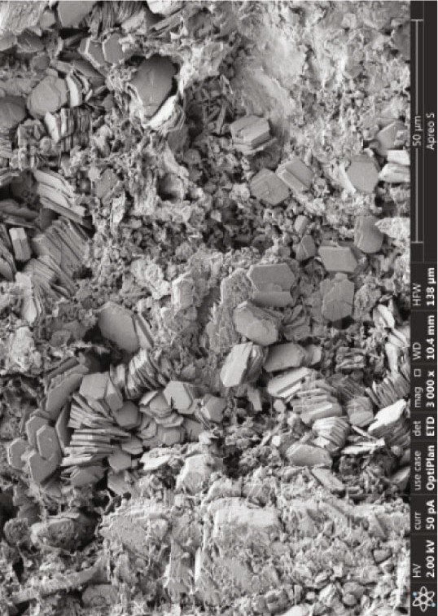
Ca
Ca
Ca
Ca
Ca
Ca
Fig.5d
Ca
Ca
Clay matrices in the pores
100 𝜇m
Ca
Small pore sizes
Ca
50 𝜇m
8
Fig.5c
(a)
(b)
Kaolinite
Kaolinite
(c)
(d)
(e)
(f)
Feldspar
(g)
(h)
Figure 5: Continued.

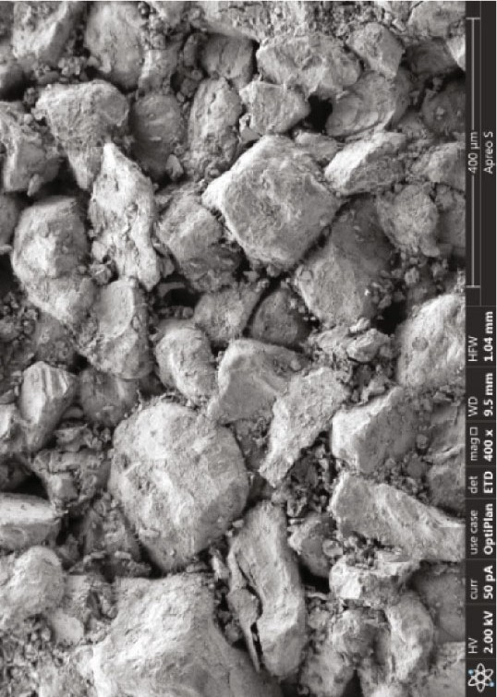
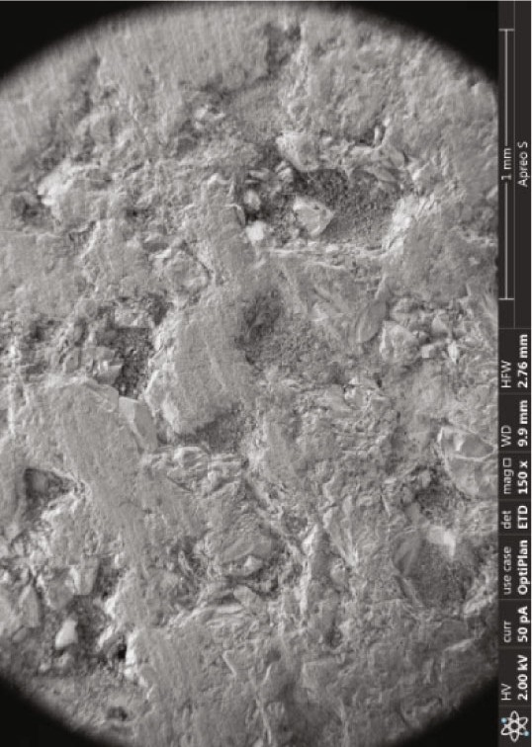

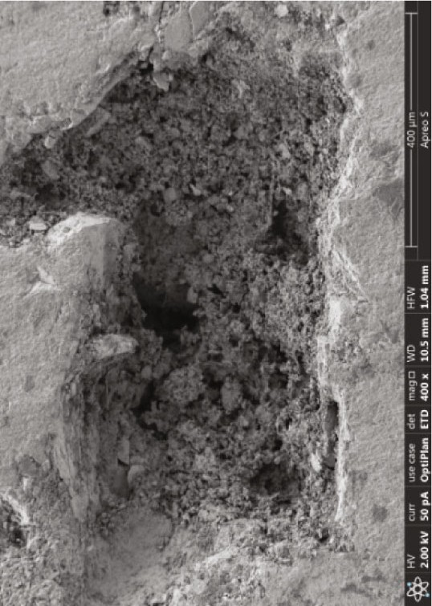
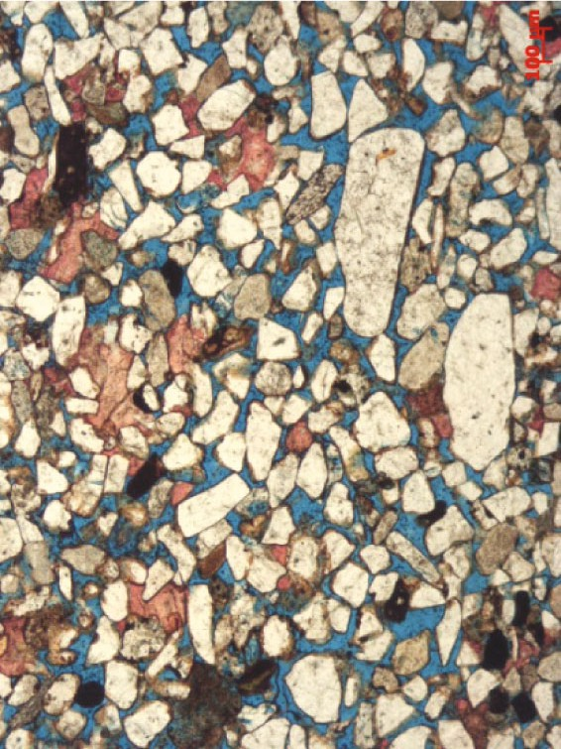
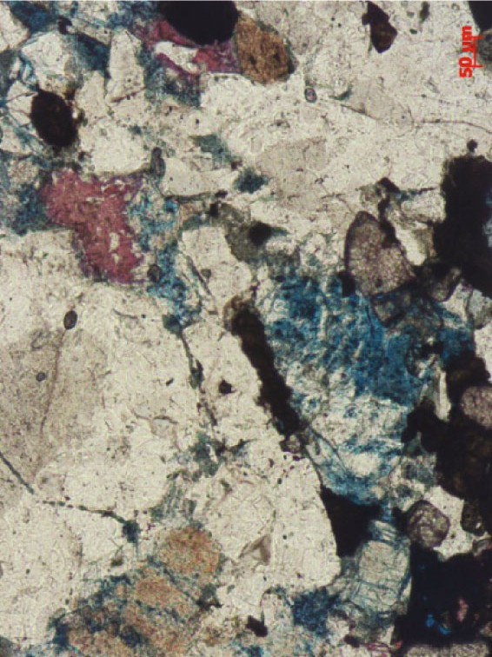
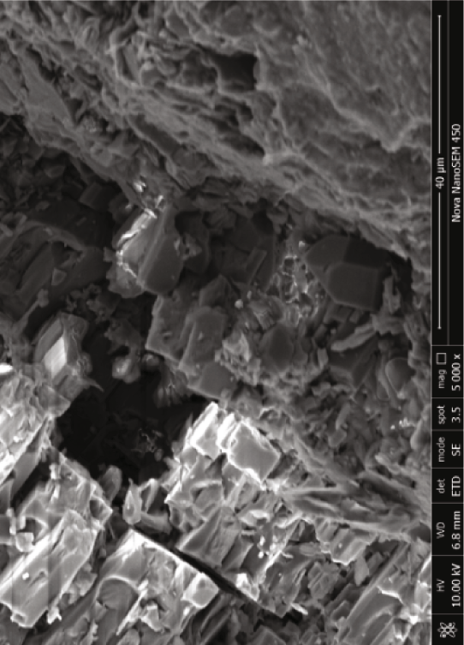
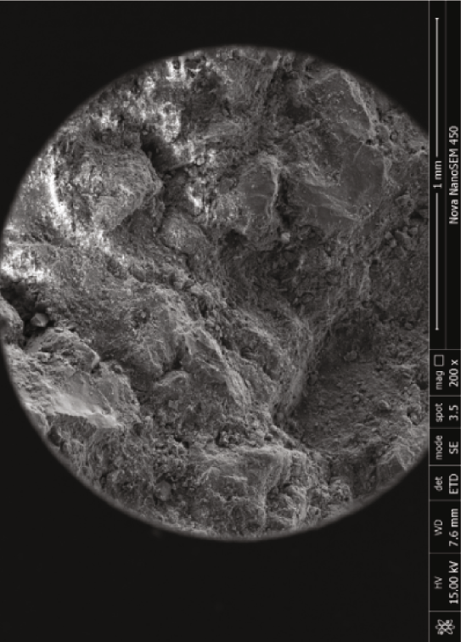

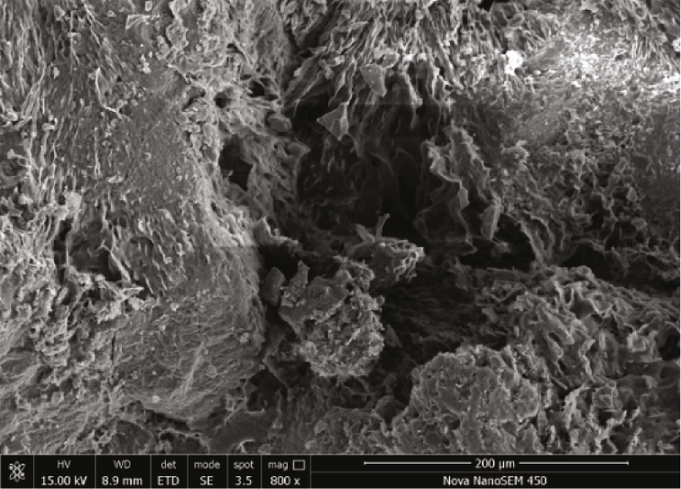
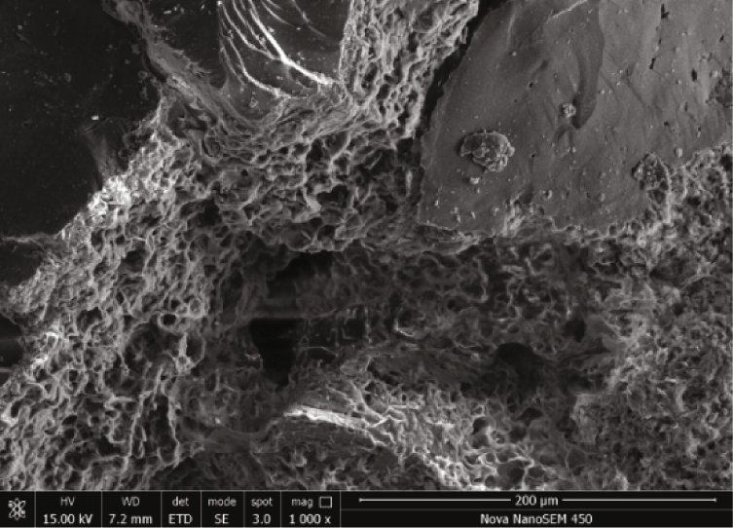
- (j)
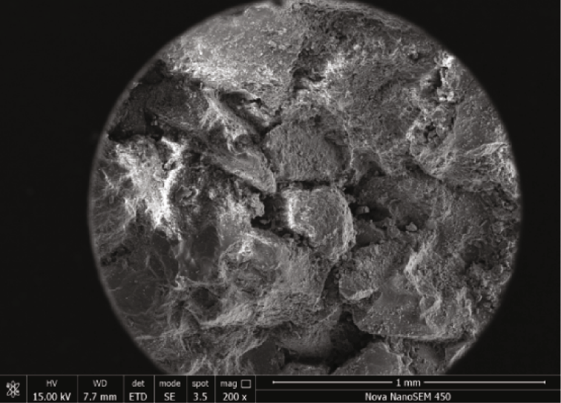
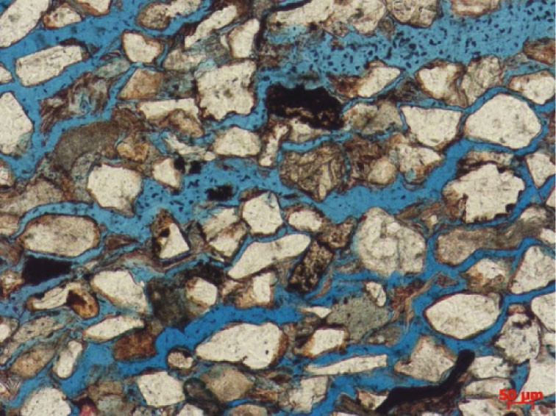
Enlarged pore sizes
50 𝜇m
(k) (l)
Figure 5: Microscopic changes in the pore structures occurring during the formation process seepage in deep water South &west Gabiley explorable fields.

Table 6: List of strata crossed by the ventilating shaft.
Strata Thickness (m) Lithological characteristics Hydrogeological feature

Quaternary system 217 Coarse, medium, and fine sandstone, clay, and
sandy clay
Lacks an important sandstone seepage section

Jurassic system 516 Fine sandstone, siltstone, and magmatic rock Contains 3 main sandstone seepage sections

Permian system 311 Coarse, medium, and fine sandstone, siltstone,
mudstone, and sandy clay
Contains 3 main sandstone seepage sections

Discussion
  - Permeability Analysis
Sandstone. Before grouting in deep South &west Gabiley explorable field pores, we need to understand the permeability of the area sandstone and in which kinds of sandstone seepage may occur. This discussion will analyze and estimate the range of values of the permeability of ground water and sandstone. Because diﬀerent strati- graphic structures or sandstone pore structures have diﬀer- ent permeabilities, the estimated permeability of sandstone is diﬀerent. Here, as a case study permeability analysis and estimation are carried out by taking the sandstone seepage on the ventilating shaft wall of the seepage occurred.
According to the geological observations obtained from the construction of the ventilating shaft in the water exploration the diameter of the shaft is 6 m, the wellhead elevation of the shaft is +139 m, and the vertical depth of the shaft is 1044 m. The strata that are crossed by the ventilating shaft from top to bottom include Quaternary, Jurassic, and Permian systems. The aquifers through which the ventilating shaft passes are mainly Jurassic sandstone aquifers and Permian sandstone aquifers. These sandstone aquifers are mainly pore aquifers with small numbers of microfractures. (water seepage outlet point may became visible during the excavation). The seepage water is in the form of “large-area sweating” and is large in volume. A total of 6 main sand- stone seepage sections occur in the bedrock below a 284 m wellhead with a total thickness of 559.4 m (see Table 6). In the construction process, conventional grouting will be carried out in the rock mass behind the wall of the ventilating shaft (see Figure 6(b)). Two kinds of slurry materials are to be used in the construction process: (a) portland cement slurry: the water cement ratio will be 0.6-2.0 and (b) Portland cement slurry with sodium silicate (SiO₂/Na₂O= 2.3 − 2.8):



Ventilating shaft
1
3 m
5 m

P_{w}

5 m 3 m
R_{e} R_{w}
8 2

Seepage direction
10 m
7 3
P_{e}
6 m
45°
h 6 4

Grouting hole 5
(a) (b)
Figure 6: (a) Cross-section and (b) plan of grouting behind the ventilating shaft wall of the Gabiley deep water hole. The yellow represents the rock strata behind the shaft wall.

The water cement ratio of the Portland cement slurry will be 1.25 : 1, and the volume ratio of portland cement and sodium silicate will be 1 : 0.8-1 : 0.4. However, the water plugging eﬀect to meet the requirements of the acceptance specification.

According to the code for the acceptance of shaft sinking and drifting of the water (GB50213-2010) [4], the total water inflow of the shafts exceeding 200 m depth shall/be more then and may not be more than 60 m³/h enough to feed Gabilley.
The following is the permeability analysis and estima- tion process of the “large-area sweating” sandstone on the ventilating shaft wall of the Gabiley water borehole to drill. To simplify the calculation, the “large-area sweating” sandstone is cal- culated as a whole without interlayers, and the “large-area sweating” seepage is in the form of radial flow, as shown in Figure 6(a). Thus, the permeability of sandstone can be calculated according to the Darcy formula of plane radial flow proposed by Amyx in1960 as shown in the fol- lowing formula.
K = (Qμ ln (R_{e}/R_{w})/2πh(P_{e} − P_{w})) (1)
where K is the permeability of sandstone, Q is the seepage amount, μ is the water viscosity, Re/Rw is the ratio of the outer diameter to the inner diameter, h is the thickness of “large-area sweating” sandstone, and (Pe − Pw) is the water pressure diﬀerence between the outer and inner sides of the ventilating shaft.
According to the geological data of the main shaft and
the ventilating shaft of the Gabiley water borehole to drill, the calculation parameters in the above formula are estimated
as follows:
- Regarding the water pressure diﬀerence (Pe − Pw), according to the People’s Republic of China (Taiwan) petro-leum natural gas professional standard (SY/T5815- 2016) [27], the water pressure diﬀerence of the shaft wall at 1 kilometer is estimated to be 11.3 MPa and equal in diﬀerent directions. Because the actual water pressure diﬀerence increases with increasing depth from top to bottom, to simplify the estimation, the water pressure diﬀerence is estimated to be the water pressure diﬀerence at half a kilometer, i.e., 5.65 MPa
- Regarding the amount (Q), according to the code for the acceptance of shaft sinking and drifting of water (GB50213-2010) [4] and assuming conditions at the limit, the seepage amount is estimated at the maximum allowable water value Qmax of the 1-kilometer shaft, i.e., 10 m³/h
- Regarding the ratio of the outer diameter to the inner diameter (Re/Rw), according to the conventional back wall grouting scheme of the main shaft and ventilating shaft of the Gabiley water borehole to drill. the distance between the water stop and shaft wall is generally 2 m, and the inner radius of the shaft is 3 m; accordingly, the outer diameter is 5 m, as shown in Figure 6(a), and thus, the logarithm of the ratio of internal and external diameters is 0.51
- The water viscosity (μ) is 1.005 × 10⁻⁹ MPa s
- Regarding the thickness of “large-area sweating” sandstone (h), considering that 6 main sandstone seepage sections of the ventilating shaft have a total thickness of 559.4 m, and only a certain proportion of the total thickness is “large-area sweating” sand- stone, to simplify the estimation, the thicknesses of “large-area sweating” sandstone are assumed to be 50%, 40%, 30%, 20%, and 10% of the total thickness,
respectively, i.e., 279.70 m, 223.76 m, 167.82 m,
111.88 m, and 55.94 m, respectively
By substituting the above estimation parameters into Equation (1), the permeability of “large-area sweating”

Figure 7: Permeability distributions of the three layers of deep South &west Gabiley explorable field.

12

The lower limit of permeability of the “large area sweating” sandstone
The permeability of deep mine sandstone (mD)

10

8
Figure 7: Permeability distributions of the three layers of deep south/west Gabiley explorable field.
6

4

2

0.25
0
Jurassic sandstone shiilcad sandstone Dixi sandstone MIN
AVG MAX

sandstone (K) can be calculated as 0.15 mD, 0.18 mD,
0.24 mD, 0.36 mD, and 0.73 mD.
According to the survey and mining data of the South- west Shandong coalfield, the average thickness of the deep South &west Gabiley explorable field in the Shiilcad Formation accounts for approximately 31% of the total thickness [33]. Therefore, it is estimated that the minimum lower permeability limit of the “large-area sweating” sandstone in the Gabiley water borehole to drill of the Southwest Shandong coalfield is approximately
0.25 mD.
According to the permeability distributions of the three layers of deep South &west Gabiley explorable field (see Figure 7), the permeability of Jurassic sandstone is more significant than 0.25 mD (minimum 0.7 mD), so all of the Jurassic sandstone is medium- to low-permeability “large-area sweating” sand- stone. The average permeability of the Permian Sandgrain and Shiilcad Formation sandstones is smaller than 0.25 mD. Nevertheless, the maximum value is more significant than
0.25 mD, so only a small portion of Permian sandstone is low-permeability “large-area sweating” sandstone.4
  - Sandstone Pores Coupled with Microfractures. In Section 4.1, the lower permeability limit of sandstone refers to the matrix permeability of sandstone without fractures. Nevertheless, mining data from the show that deep borehole of South &west Gabiley explorable field often contains several fractures. many microfractures occur in the deep South &west Gabiley explorable field, and the water inrush phenomenon of pore sandstone frequently occurs, so the second-phase sinking and driving engineering needs the support of curtain grouting, which can slow the progress of the project. In addition, studies have shown that the development of bedding fractures and structural fractures can significantly improve the connectivity of the pore structure of sandstone and increase the permeability. Therefore, when diﬀerent numbers of microfractures are coupled with pores in deep South &west Gabiley explorable field, the lower permeability limit of sandstone can be less than 0.25 mD.
  - Recommendations for the Prevention of “Large-Area Sweating” Water Seepage. The efficiency and safety of under- ground drilling is very important. If seepage of sandstone pores is not eﬀectively controlled in a timely manner, normal production will be stopped, the shaft will even be scrapped, and the economic loss will be very severe. Based on our understanding of its formation mechanism, water borehole for sweat water from deep South &west Gabiley explorable field pores can be achieved eﬀectively from aﬀecting production by paying considerable attention to the following three aspects of the work done during construction and rapid production expansions of deep cborhole water construction

Summary and Conclusions

Taking the deep South &west Gabiley explorable field in the South &west Gabiley explorable field, where “large-area sweating” seepage has occurred, as an example, this study analyzed the formation mechanism of “large-area sweating” water seepage based on the pore structure and petrological characteristics of the sandstone. In addition, the permeability ranges of sandstone in which “large-area sweating” seepage may occur was discussed. The main findings of this study are as follows:
- The deep South &west Gabiley explorable field in the Southwest Shandong coal mine has three prominent petrological characteristics. First, the compositional maturity is low to relatively low, which manifests as high contents of feldspar and rock debris grains in the sandstone. Second, the textural maturity is immature to secondarily immature, which manifests as a high matrix content in the sandstone (generally 5%~12%). Third, many calcareous cement types are present in the interstitial materials, except for the matrix. The above petrological characteristics laid an internal material foundation for various late diagenetic changes in the deep South &west Gabiley explorable field pore structure
in deep South &west Gabiley explorable field, the lower permeability limit of sandstone can be less than 0.25 mD
- This study proposed the concept of “sweating” water seepage in sandstone pores, analyzed the formation mechanism of “large-area sweating” water seepage in sandstone under deep shaft environmental conditions, and discussed the permeability range of sand- stone in which water seepage may occur. These findings contribute to a better under- standing of the formation mechanism of “large-area sweating” seepage from deep South &west Gabiley explorable field pores, so that it is possible to predict, prevent, and stop the formation of “large-area sweating” water seepage from deep South &west Gabiley explorable field pores

Abbreviations
Q: Quaternary system
J₃: Jurassic system
P₂: Permian sandgrain Formation P₁: Permian Shiilcad Formation 3A: 3A coal layer
K: Sandstone permeability (mD)
Q: The seepage amount (m³/h)
Qmax: The maximum allowable water seepage value (m³/h) h: The thickness of “large-area sweating” sandstone (m) μ: The water viscosity (MPa.s)
Re: The outer diameter of the ventilating shaft (m)
Rw: Inner diameter of the ventilating shaft (m)
Pe: Water pressure at outer side of the ventilating shaft (MPa)
Pw: Water pressure at inner side of the ventilating shaft (MPa)

Data Availability
The data used to support the findings of this study are included within the article.

Conflicts of Interest
The authors declared that they have no conflicts of interest to this work.

Acknowledgments
This work was supported by the National Natural Science Foundation of Somaliland Republic ministery of water and the MInistery of National Planing.

References
- H. Wang, W. Xu, C. Jia, M. Cai, and Q. Meng, “Experimental research on permeability evolution with microcrack develop- ment in sandstone under diﬀerent fluid pressures,” Journal of

Geotechnical and Geoenvironmental Engineering, vol. 142, no. 6, 2016.
- P. Ranjith, J. Zhao, M. Ju, R. V. S. de Silva, T. D. Rathnaweera, and A. K. M. S. Bandara, “Opportunities and challenges in deep mining: a brief review,” Engineering, vol. 3, no. 4,
pp. 546–551, 2017.
- Z. W. Qian, Z. Q. Jiang, L. W. Cao, and Q. Sun, “Experiment study of penetration grouting model for weakly cemented porous media,” Journal of China Coal Society, vol. 34, no. 1,
pp. 139–142, 2013.
- Standardization Administration of China, Code for Acceptance of Shaft Sinking and Drifting of Coal Mine: GB50213-2010, China Planning Press, Beijing, 2010.
- J. Zhang and Y. Xiang, “Discussion on specified total water leakage of vertical shafts in standard,” Coal Engineering, vol. 47, no. 10, pp. 21–23, 2015.
- N. Wu, X. Zhang, and M. Li, “Research on new grouting equip- ment and method for the treatment of gushing water in poros- ity sandstone,” Journal of Shandong university (engineering science), vol. 45, no. 4, pp. 64–68, 2015.
- T. Mautusinovic, J. Sipusic, and N. Vrbos, “Porosity-strength relation in calcium aluminate cement pastes,” Cement and Concrete Research, vol. 33, no. 11, pp. 1801–1806, 2003.
- A. Ozturk and B. Baradan, “A comparison study of porosity and compressive strength mathematical models with image analysis,” Cement and Concrete Research, vol. 43, no. 4,
pp. 974–979, 2008.
- R. Harris and R. Bustin, “Diagenesis, reservoir quality, and production trends of Doig Formation sand bodies in the Peace River area of Western Canada,” Bulletin of Canadian Petro- leum Geology, vol. 48, no. 4, pp. 339–359, 2000.
- S. Paxton, J. Szabo, J. Ajdukiewicz, and R. Klimentidis, “Con- struction of an intergranular volume compaction curve for evaluating and predicting compaction and porosity loss in rigid-grain sandstone reservoirs,” AAPG Bulletin, vol. 86,
pp. 2047–2067, 2002.
- K. Higgs, H. Zwingmann, A. Reyes, and R. Funnell, “Dia- genesis, porosity evolution, and petroleum emplacement in tight gas reservoirs, Taranaki basin, New Zealand,” Journal of Sedimentary Research, vol. 77, no. 12, pp. 1003–1025,
2007.
- P. Nicholson, W. Esch, and J. Ajdukiewicz, “Prediction of deep reservoir quality using early diagenetic process models in the jurassicnorphlet formation, gulf of Mexico,” AAPG Bulletin, vol. 94, no. 8, pp. 1189–1227, 2010.
- J. Lai, G. Wang, Z. Wang et al., “A review on pore structure characterization in tight sandstones,” Earth Science Reviews, vol. 177, pp. 436–457, 2018.
- T. Le Borgne, O. Bour, F. L. Paillet, and J. P. Caudal, “Assess- ment of preferential flow path connectivity and hydraulic properties at single-borehole and cross-borehole scales in a fractured aquifer,” Journal of Hydrology, vol. 328, no. 1-2,
pp. 347–359, 2006.
- A. Mukai and K. Fujimori, “Secular change of permeability in the fracture zone near the Nojima fault estimated using strain changes due to water injection experiments,” Tectonophysics, vol. 443, no. 3-4, pp. 193–199, 2007.

SN | Description Input Activities | UNIT | Qty | UP | $Total
 | Site mobilization and preparation for project | Nos | 01 | 3000 | 3000
 | Equipment and materials move to site | Nos | 01 | 2500 | 2500
 | Validating the water side prior to drilling through geological exploration and traditional methods. | Nos | 01 | 7800 | 7800
 | Initiate the drilling of eight 14” diameter in deep pore hole. | Nos | 01 | 2000 | 2000
 | Drill first hundred meters | LM | 100 | 250 | 25000
 | Drill second eighty meters | LM | 100 | 350 | 35000
 | Prepare and install the casing/screen types. | LM | 50 | 200 | 10,000
 | Install the remaining of hundred meters. | LM | 150 | 200 | 30,000
 | Construct the grout of the well | LS | 01 | 2000 | 2000
 | Provide 15cm² borehole dump protection refill the gravel to two CM between the casing and the ground mud of the borehole | L S | 01 | 3000 | 3000
 | Develop and Clean the Bore hole with water compressor of a pressure to 20bars and above | Nos | 01 | 5000 | 5000
 | Provide and install SP60/200 Test pump for 24 hours to make sure the aquiver and yielding to satisfy the 120/2M³ demand of the Gabilley town. | Nos | 01 | 4000 | 4000
 | Provide and install 40KW generator for 24 hours to make sure the aquiver yielding to satisfy the 120/2M³ demand of the Gabilley town. | Nos | 01 | 4000 | 4000
 | Provide and purchase and install SP60/200 permanent pump with temperature protection, water drop electrodes and panel board. for good yielding to satisfy the 120/2M³ demand of the Gabilley town. | Nos | 01 | 5000 | 5000
 | Provide and install 40KW generator for good to make sure an aquiver yielding to satisfy the 120/2M³ demand of the Gabilley town. | Nos | 01 | 15000 | 15000
 | Construct the generator room with ventilation exact to the radiator of the generator, blowing the hot engine Air out, ventilation windows at the bottom of the engine room to get the room hot air out and upper ventilations on top of the lintel R.R.C. so the cold air moves down to keep the room temperature cold to 40C⁰ | Nos | L.S. | 9500 | 9500.
 | Construct The staff room the operator and the helper and the watchman. | Nos | L.S. | 8500 | 8500
 | Construct a fence of the compound for protection | Nos | L.S | 3000 | 3000
Subtotal |  |  |  |  | $174,300
 | For two Boreholes $174,300 x2. |  |  |  | 348,600
 | Administration Cost 20% |  |  |  | 069,720
 | Produce and install Riser main to connect to Town reservoir |  |  |  | 220,000
Sub Total of the 2 Borehole drilled, equipped, operated, & staff trained cost |  |  |  |  | $ 638,320

Eng Ahmed abdikariim Ibrahim Guddoomiyaha ururka injineerada Somaliland.
boqor2010@gmail.com Gudoomiyeahmed@Ururkainjineerada Somaliland.com



